THE 2014 B.A.A. BOSTON MARATHON
RACE DIRECTOR – PERSONAL REFLECTIONS

This year was hard, it was very hard in many ways. Bart Yasso from Runner’s World Magazine declared it “the most significant marathon in the history of the sport.” No pressure there…yeah, right!

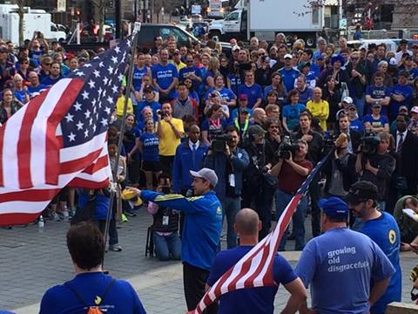
FINISH OF THE ONE RUN FOR BOSTON RELAY
ACROSS AMERICA

Since April 15, 2013, we have had to get through three monumental stages. First, we needed to process all of it, recovering as best as possible and then go through some healing. Next, we desperately were trying to conceptualize what 2014 would be. So many from around the world offered ideas, suggestions, recommendations, I mean by the hundreds – it was overpowering. So, what would the 2014 race look like? And, finally, the delicate planning and then the execution of the plan – yes, what we do best. But all of this just didn’t leave us much time, maybe 5 months tops. With an additional 9,000 runners and the additional layers of high level security, the challenge became daunting and overwhelming at times. All this being said, as the management team, we needed to continually keep our “game face” on and not lose sight of the fact that we were still obligated to produce a world-class road race.
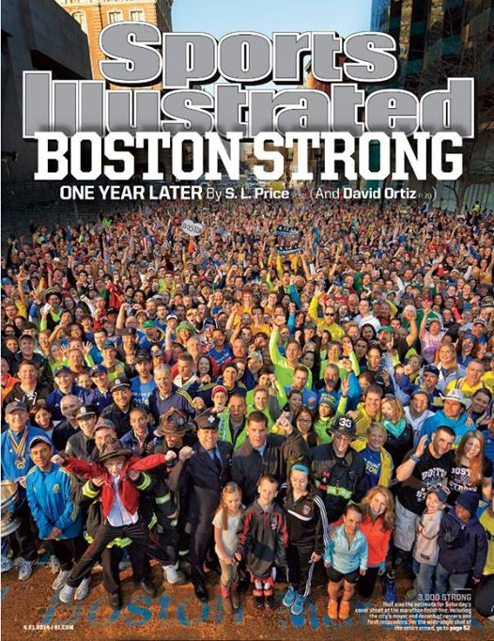
SPORTS ILLUSTRATED COVER

On two occasions a few weeks before the race, many of us were invited back to the finish line for a photo – one for the cover of the Boston Globe and one for the cover of Sports Illustrated! Imagine, on the cover of SI – now I’m hoping we don’t suffer the curse of the SI cover!

Driving to the office the week before the race, I received a phone call from Creigh Kelley, a follow race director in Denver, CO. He asked how I was doing and I said great and he replied, “good, the entire country is counting on you!” Huh? The entire country? At first I wasn’t real sure how to interpret that but I then just took it as a compliment and moved on. The entire country! Wow. No pressure there, either.

Were we indeed ready? For the first time in 27 years of doing this, I really wasn’t totally sure myself. This was a very different feeling. We were close but were we indeed “all set”? I truly thought some things may not go as well as we had hoped, just too many moving parts and too many people involved. But in the end and to my amazement, I was dead wrong, relatively speaking. During the final planning month, we kept plugging and plugging and plugging away. Many things did seem to come down to the wire, something I am not used to and don’t like but we had no choice this time around. I certainly don’t ever want us to be put in that position again if we can help it…never again.

The week started with a very emotional remembrance ceremony at the Hynes – The Tribute - on April 15th, exactly one year from the tragedy. It was both sad and inspirational at the same time. Once the American flag was raised at the finish line on Boylston Street, it signified that we had finally made it back and now were about to “move forward”, never forgetting but not looking back as much anymore, just looking ahead. It was time to put on a road race but not just any road race. This is the Boston Marathon and this one would be historic.

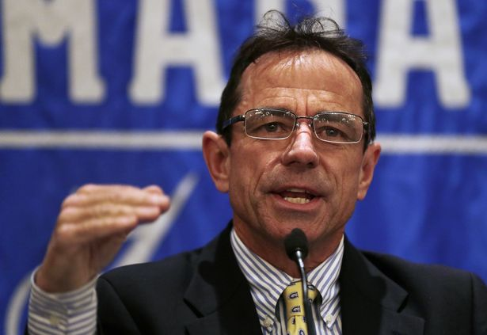
PRE-RACE PRESS CONFERENCE

Friday night I attend a charity function put on by CharityTeams. Amby Burfoot and I spoke there along with the man himself, Meb Keflezighi. Meb and I and his brother Hawi walked back to the hotel together (a little over a mile) and Meb and I talked about his strategy for Monday. Hmmmm…little did I know what was about to come…we now know his strategy worked pretty well!

The four running events we produced on Saturday were cathartic. First up was the BAA 5K with 10,000 runners. Then the Tribute Run with 1,000 participants comprising of survivors, families of the victims, first responders and many other One Fund supporters. The survivors had a chance to participate in a BAA event, all the while reclaiming Boylston Street. One emotional story after another came across the finish line each full of hugs, kisses and tears.

This was followed by the traditional BAA Invitational Miles and the Kid’s Relay races. All went magically well under beautiful weather conditions. Henry Richard, older brother of little Martin who lost his life at the finish line last year, participated in the relay. As I watched him run, I became a little choked up. How does that family do it? They came right back where it all happened and refused to give in. How can that not inspire you?

On Saturday and Sunday I made a few appearances at the Runner’s World clinics which are always a highlight for me. Later Sunday afternoon I made quick stop at the Dana-Farber Marathon Challenge pasta dinner to say a few words to the group. Wow…they had to have close to 600-700 in attendance, maybe more.

On Sunday night, the BAA was invited to the opening ceremonies at Fenway Park which was dedicated to the marathon. It was a touching ceremony which included BAA volunteers, first responders, survivors and One Fund runners. One highlight for me was running in side-by-side with the Rick and Dick Hoyt. I’ve personally run into Fenway many times, but this one was different and very special showing the country that we were back, that we were Boston Strong(er).

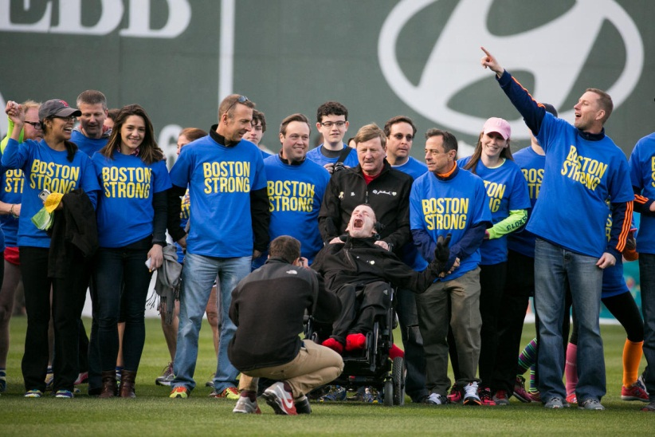
PR-GAME CEREMONIES AT FENWAY PARK

After the ceremonies, I headed back to the Fairmont Copley Plaza Hotel and made a very quick appearance at a John Hancock function. Little did I know I would end up in a photo with some of Boston’s most treasured superstars. Even while standing on a chair it was difficult to look some of them straight in the eye!

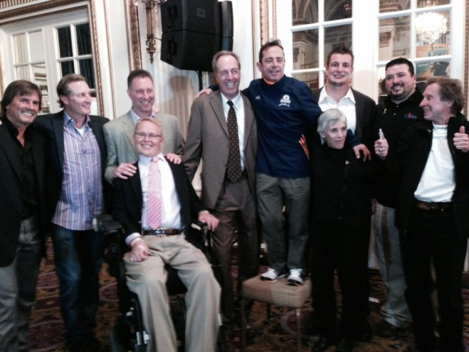
DENNIS ECKERSLEY (RED SOX), STEVE LYONS (RED SOX), BOB SWEENEY (BRUINS), TRAVIS ROY (BU HOCKEY), DAVE COWENS (CELTICS), ROB GRONKOWSKI (PATRIOTS), JOANIE SAMUELON (OLYMPIC GOLD MEDALIST), JOE ANDRUZZI (PATRIOTS), BILL RODGERS (4-TIME BOSTON WINNER).

Next up was what we all had been waiting for an entire year, the 2014 Boston Marathon. People continually asked me – are you scared, are you nervous? I was neither, but, I was full of anxiety. However, I did find myself “looking around” a lot more this year. I didn’t know what to expect. This thing was so much bigger than ever before with so many more people involved. I felt I had lost some control of whatever little I once might have had. Although most of it was the same, some of it was very different.
It was also a little sad that my family would not be attending the race this year but I totally supported this decision. I’m sure they will all be back next year!

However, the day didn’t start out on the right foot for me. The person who was assigned to pick me up couldn’t start the new electric car that was to serve as one of our lead vehicles. I was hoping my own personal marathon wasn’t going to end up being a run from Boston to Hopkinton versus the other way around. Another vehicle was summonsed and picked me up. Then I heard about a traffic accident on one of the highways and thought, oh great, major traffic tie ups. Once in Hopkinton, all seemed to be going very smoothly…until…BANG! A loud bang occurred at the Village and everyone was prepared to evacuate. Fortunately, it was immediately determined that a bus tire blew in the parking lot. Now why would something like that happen for the very first time, especially THIS year!

First up were the military marchers from the National Guard. I spoke to them as a group at 6am…my goodness, I never had a group of people pay such close attention to me more than these folks did. Guess that is what you learn in the military…I need to send my children there for some quick lessons. At about 6:20am, I sent them on their way to Boston…about 100 of them. Very inspiring way to start the day.

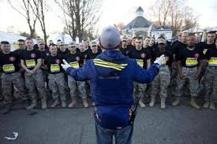
SPEAKING TO ALL THE MILITARY MARCHERS

Although flattering, I had to do a number of media interviews which simply adds a little more pressure to the morning given the very tight timeline. Additionally, the BAA is having a documentary film made of the 2014 race and as such I was being “shadowed” the entire day by camera totting videographers. I know the end result will be stunning, but it can be a little nerve wracking knowing your actions are being recorded every moment of the day. At least they didn’t follow me into the portable restrooms!

Next up was the 8:50pm mobility impaired division. Governor Deval Patrick arrived and stood next to me to serve as the official starter. After a very powerful moment of silence in remembrance of the tragedy last year, the Governor officially started the race precisely on time and sent about 25 athletes on their way to Boston.

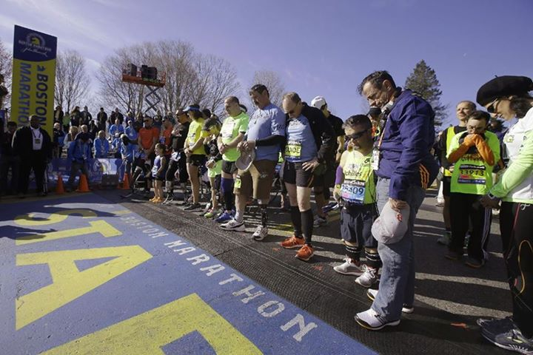
MOMENT OF SILENCE AT START

Next, we loaded the wheelchair participants, then the duo’s including the Hoyts and then the handcycles. Again, all went off as planned. The elite women then arrived and off they went and then the elite men came out. That’s when I took a deep breath and truly paused by myself for a moment. After 12 long, hard months we were minutes away from sending off 36,000 runners from Hopkinton to Boston. What a relieving feeling that was. It was truly an “epic” moment.

I jumped on a motor scooter and Andy Deschenes, Start Coordinator, took over. The gun fired at 10:00am and we were off. The crowds were amazing, greater and deeper than I have ever seen in my 27 years and by a ton! The crowd control was amazing, too. I didn’t see one person jumping out onto the street. Later, I was also informed that ONLY 15 non-registered runners (without bibs) jumped into the race at the back of the pack in Hopkinton. That was incredible. Even the general public heeded our requests this year…EVERYONE was cooperating, I mean EVERYONE.

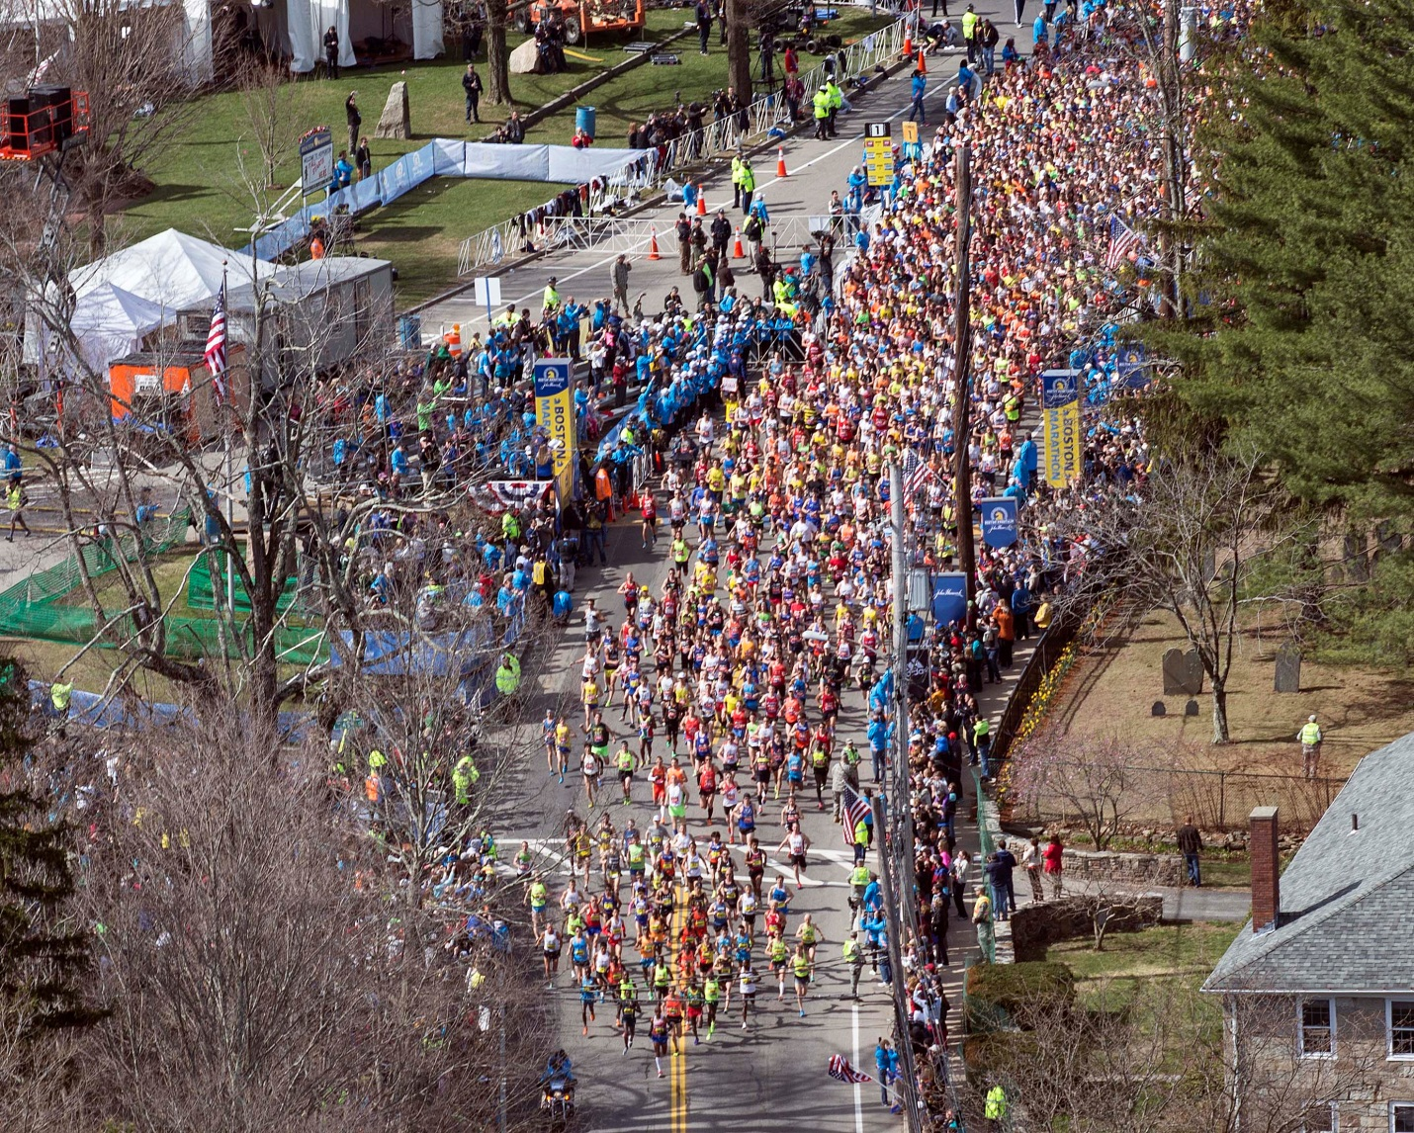
THE 2014 BOSTON MARATHON IS UNDERWAY

And what a race it was. It was so inspiring as we caught up to all the mobility impaired participants and wished them well as we went by. Very touching indeed.

Meb was so gutsy to take it out like that and keep the lead. I’m sorry but even I had my doubts near the end when the gap shrunk from 45 seconds to 8 seconds…why wouldn’t I? But, Meb dug deep and pulled it off. Outstanding…first American male winner in over 30 years. It doesn’t get any better than that! I greeted Meb at the finish thinking this guy is first and in about 11 hours I will be back here again myself finishing last!
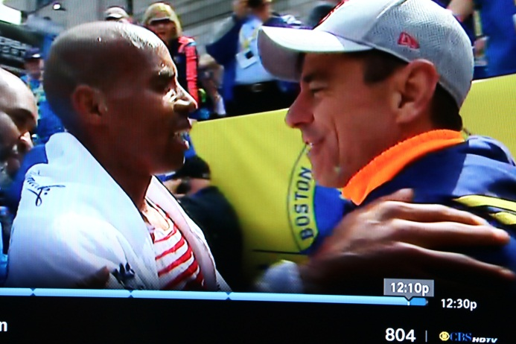
EMOTIONAL GREETING AT THE FINISH LINE

As I look back on the overall execution of the race, even I am amazed. Guilty as charged…I was wrong in terms of thinking that many more things would not go as well as they ended up doing so. Of course, that is all due to a lot of hard work and a dedicated and experienced team of professionals at the BAA, DMSE and working with so many other groups.

And finally, it was my turn. Because of what happened last year, it was decided that I would wait at the finish line until close to when the clocks were to shut down at a little after 6pm. I then headed back out to Hopkinton to begin my 42nd Boston at about 7pm. No fanfare, no large crowds, just a few friends. Sean Ryan from Green Bay, Doug Kaplan from Chicago and a new friend Brent Richardson from Chester, NH joined me.

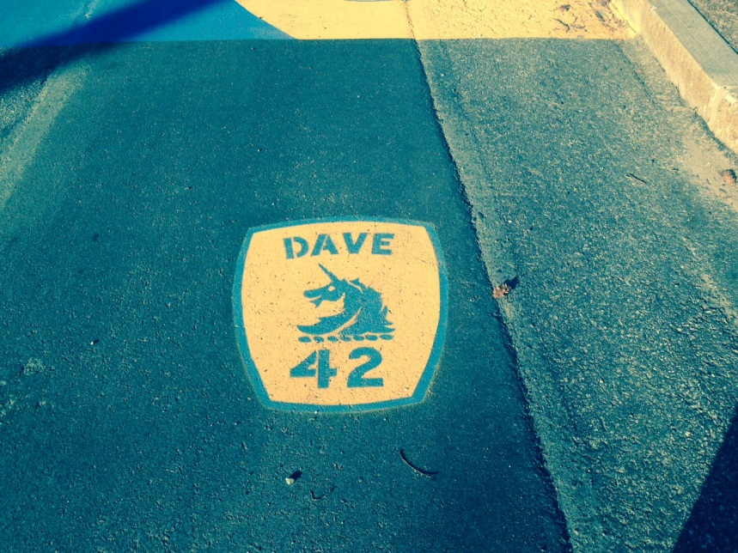
JACK LEDUC PAINTED THIS “42” AT THE START

Of course, two kind State Troopers lead the way once again helping us along the course. For the most part, the run was pretty easy, especially the second half. I seemed to be getting stronger as the run progressed towards Boston. However, it was later than usual and I was getting tired from the long day. As such, there were a few moments when I felt I was on the edge of bonking but I quickly recovered. My legs never once bothered me. But it was dark and unusually quiet for most of the run. I ran on behalf of the MR8 Foundation, in memory of young Martin Richard who tragically lost his life last year at the finish line. I thought of Martin the entire way which also seemed to give me the much needed strength to make it through the rest of the day. Collectively, Team MR8 raised an amazing $1.2 million in memory of Martin.

One of DMSE’s guys who worked the Athletes’ Village, Brian Knight, decided he’d be the jokester in group and drove down course stopping at all the bars and dragging out patrons to cheer us on. It was quite funny actually.

I finish at 11:09pm.

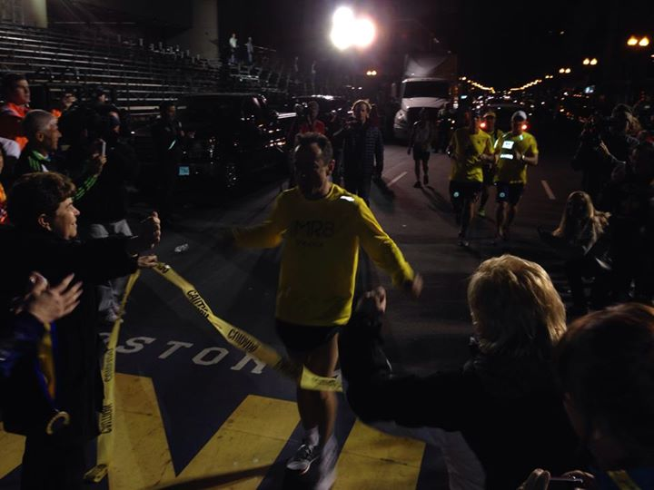
LAST AGAIN!

A nice crowd had assembled of family members, running friends and media. Even Lance Armstrong was there to greet me…very nice of him. So, Meb was first American and I was the last American and about 33,000 others finished in between. We finally got our race and finish line back!

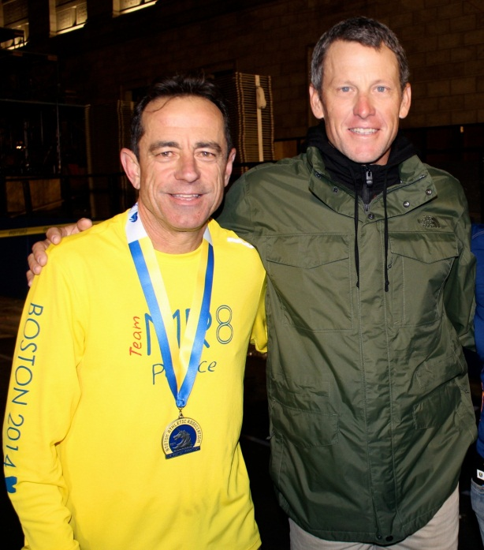
NICE OF LANCE TO GREET US

And on April 30th, the Boston City Council presented Tom Grilk and the BAA with an official proclamation and also named it Dave McGillivray Day in Boston – I asked if that got me something like free parking in the City of Boston or dinner for two and they just laughed at me! It was a very kind gesture just the same.

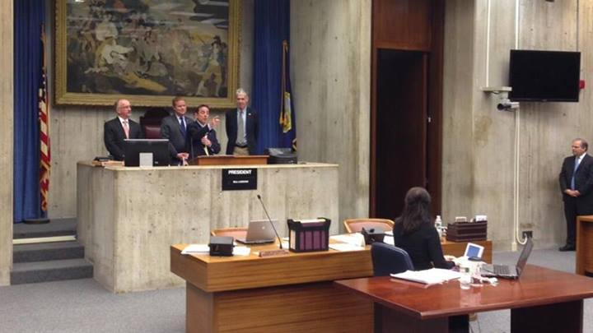
BOSTON CITY COUNCIL PRESENTATION

Now it’s time to bring on the 2015 Boston Marathon! I’ll be back. I suppose a few others will be, too!

Dave McGillivray
Race Director

